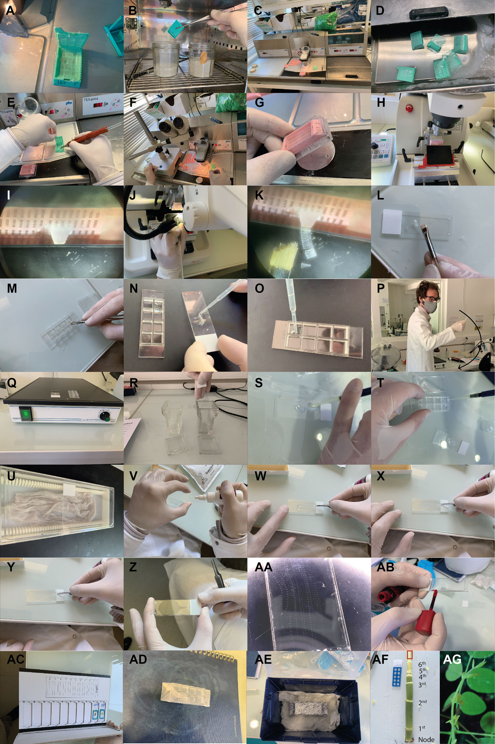
6th

^{t}
4th

^{t}
5th

^{t}
3rd

^{t}
2nd
^{t}
Node
1st
Supplemental Figure 1. Photographic illustration of the main points of the protocol. (A) Transfer the sample to biopsy cassette (Step B5). (B) Replace the Histoclear with paraffin (Step B6). (C) Hot paraffin embedding station (Step B7). (D) Biopsy cassette in the embedding station floating in melted paraffin (Step B8). (E) Transfer of the samples from the biopsy cassette to the mold using electric heatable forceps (Step B9). (F) Samples are positioned perpendicular to the cutting plane. (G) Rapid solidification of the paraffin achieved using a cold surface (small round metallic plate shown in the photo) (Step B10). (H) Samples positioning on the microtome (Step B13). (I) Binocular view of the samples facing the knife of the microtome (Step B13). (J) Serial cuts obtained by the microtome and captured using a brush (Step B14). (K) Microscopy view of the serial cuts (Step B14). (L) Position the cutes on the surface that was facing the knife on a charged slide (M) and on an Ibidi slide (Step B14). (N, O) Add a droplet of water between the slide and the cut (Step B15). (P) Remove the remaining water by manually spin-dry the slide (Step B17). Wearing a facial mask and gloves at this stage is needed only during the epidemy. (Q) Leave to dry overnight at 37 °C (Step B18). (R) Successive baths of Histoclear and ethanol for deparaffining and rehydration (Steps B19 and B20). (S) 200 µl of reagent applied on a slide or (T) 50 µl applied to a single well of a 8-well ibidi slide (Steps C1-C5). (U) A home made humidified chamber for antibody incubation (Steps C1-C5). (V) Mounting media with antifade reagent droplet on the coverslip (Step C7). (W, X, Y, Z) Gently lower the coverslip with the micro tweezer (Step C7). (AA) Serial cuts from three samples on the same slide facing each other for the comparison of different conditions. (AB) Seal the coverslip with nail polish (Step C7). (AC) Keep the slide in the dark at 4°C (Step C7). (AD) Seal the ibidi slide with parafilm (Step C8). (AE) The ibidi slide wrap in the parafilm and aluminium foil and stored at 4 °C in a humidified chamber (Step C8). (AF) The immature regions of Maize leaves (before their emergences) with a shoot tip after the removal of mature leaf tissues and leaf at 6th node enclosed with red line square was used. (AG) Star fruit plants.
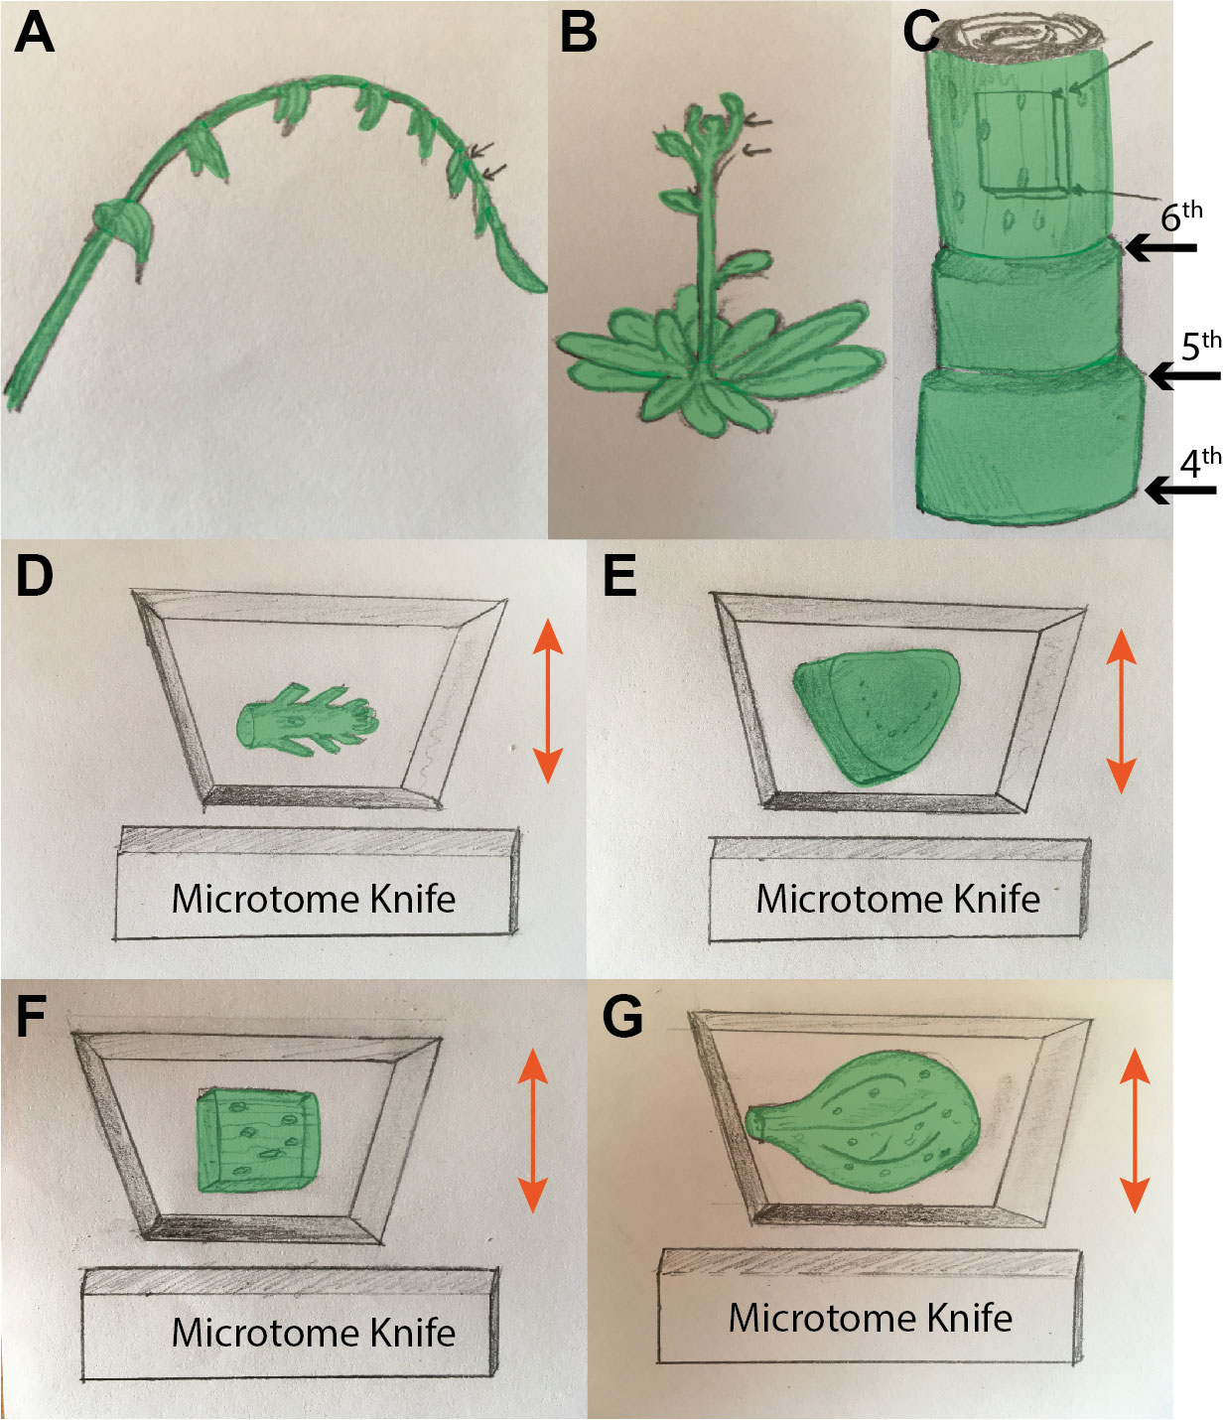
Supplemental Figure 2. Schematic representation of the tissue explants preparation and samples positioning for sectioning with a microtome, before fixation of (A) Star fruit rachis (B) Arabidopsis meristem, and (C) Immature regions of Maize leaves with a shoot tip. Black arrows indicate the area for a leaf explant upper the 6th node (see also Supplemental Figure 1AF). The positioning of a sample block on the microtome (D) for longitudinal cuts of Arabidopsis meristem, (E) longitudinal cuts of Arabidopsis cotyledons to observe its L2 layer, and pavement cells (cut parallel to the cotyledon surface), (F) longitudinal cuts of immature Maize leaf to observe pavement cells, and (G) transversal cuts of star fruit rachis. The microtome knife (presented next to the sample block) blade is highlighted in the shaded grey area. The cutting direction is indicated by double head arrows in the image plane, and the direction of the observation under the microscope is perpendicular to the image plane.

